**OS LAB-4-SHELL SCRIPTS**

1) Write a menu driven program using if-else-if conditions to perform arithmetic operations. Read two numbers and choice of operation from command line.​

read -p "Enter first number:" a

read -p "Enter second number:" b

echo "1.ADD 2.SUBTACT 3.MULTIPLY 4.DIVIDE"

read -p "Enter the operation: " n

if [ "$n" == "1" ]; then

add=$(( $a + $b ))

echo $add

elif [ "$n" == "2" ]; then

sub=$(( $a - $b ))

echo $sub

elif [ "$n" == "3" ]; then

mul=$(( $a * $b ))

echo $mul

else

div=$(( $a / $b ))

echo $div

fi

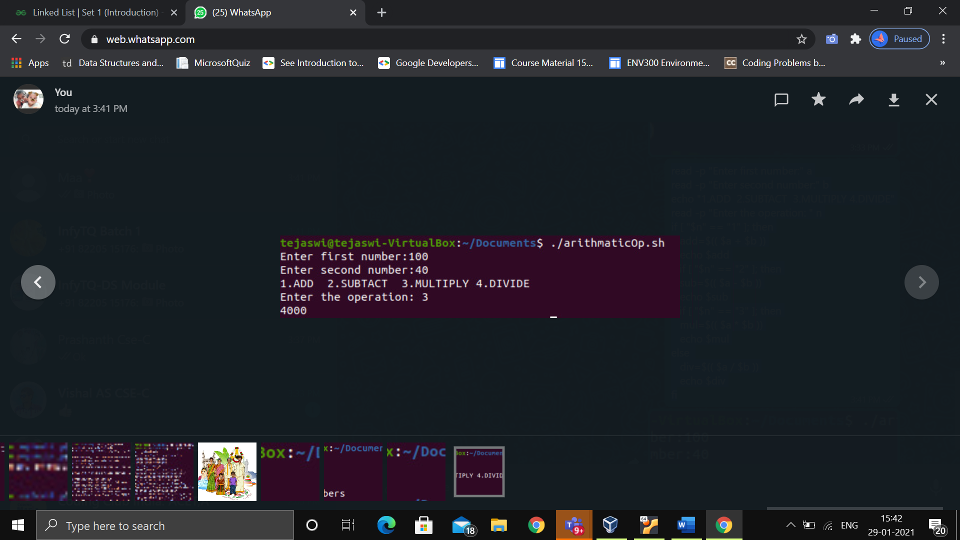

2) Write a program to check if number if even or odd.​

read -p " Enter number :" a

if [ $((a%2)) == 0 ];then

echo "EVEN"

else

echo "ODD"

fi

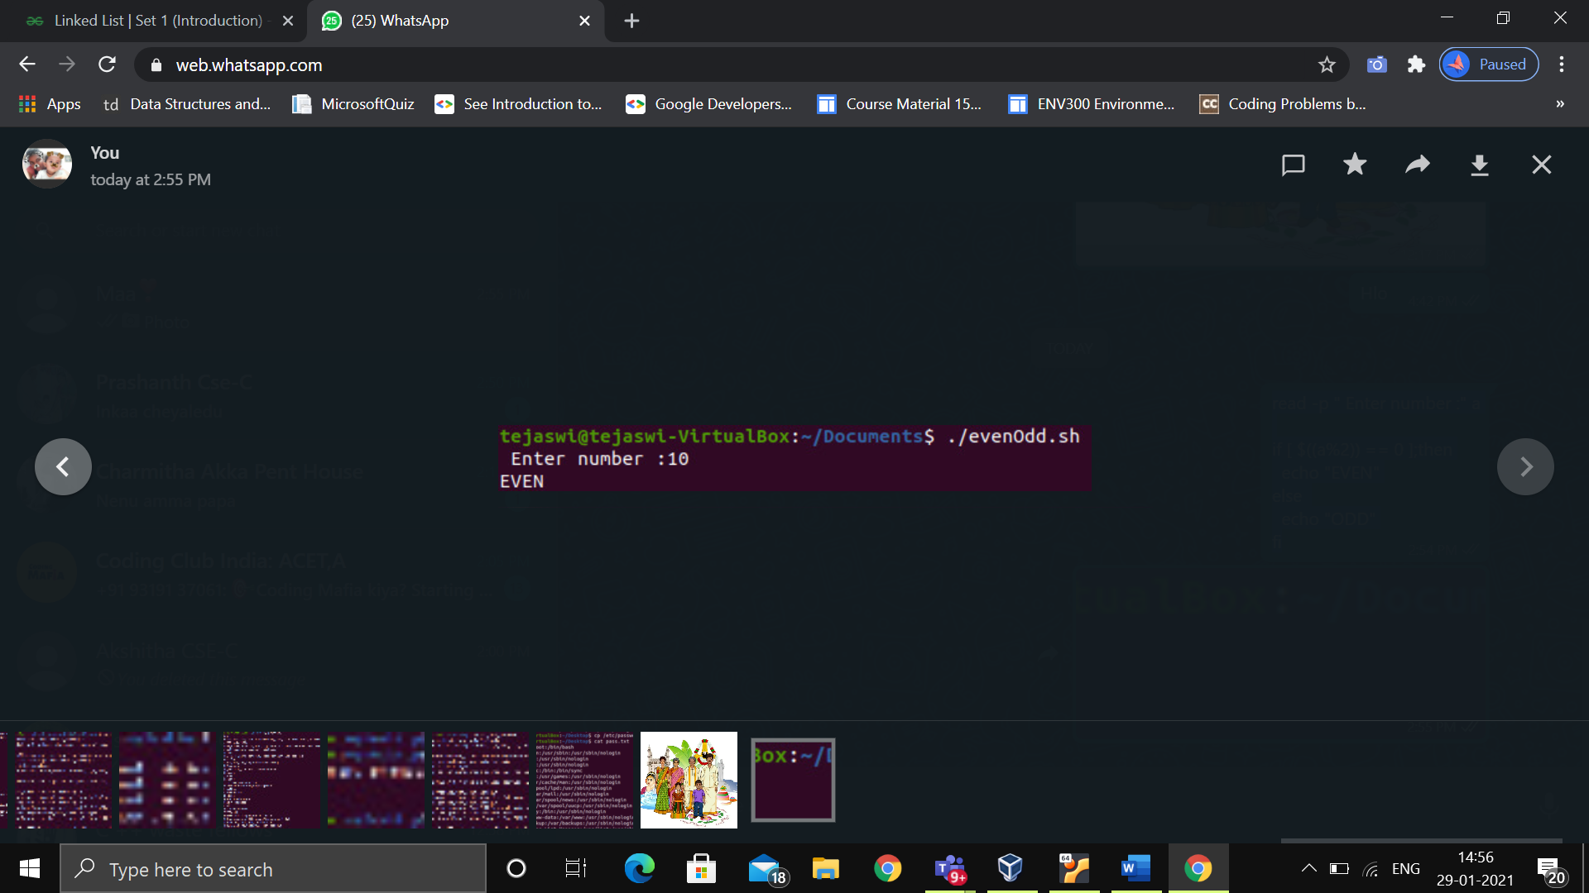

3) Write a program to print the largest number amongst three given numbers. ​

read -p "Enter 1st num: " a

read -p "Enter 2nd num: " b

read -p "Enter 3rd num: " c

if [ $a -gt $b ] && [ $a -gt $c ]

then

echo " $a is greatest of 3 numbers"

elif [ $b -gt $a ] && [ $b -gt $c ]

then

echo " $b is greatest of 3 numbers"

else

echo " $c is greatest of 3 numbers"

fi

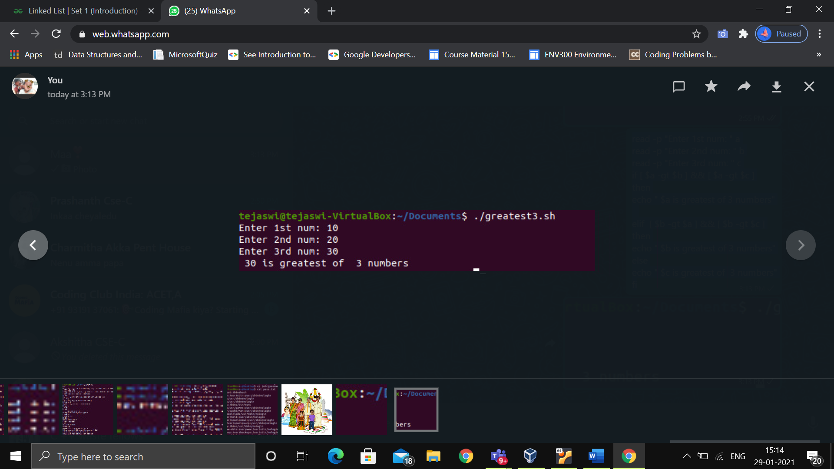

4) Write a program to calculate factorial of number. Read the number form command line

read -p " Enter number :" n

fact=1

for ((i=1;i<=n;i++ ))

{

fact=$((fact * i))

}

echo "Factorial of $n is $fact"

